West Virginia Board of Examiners for Speech-Language Pathology and Audiology

August 23, 2023 Board Meeting
Time: 5:00 PM
Location: Video Conference Meeting Board Office
99 Edmiston Way – Suite 214
Buckhannon, WV 26201

Present: Board President, Vernon Mullins Board Secretary, Vickie Pullins Board Member, Michael Zagarella Board Member, Heather Waselchalk Board Member, Amber Settles
Citizen Member, Joe E. Richards
Joanne Vella, Assistant Attorney General
Executive Director, Pamela Coughlin

The meeting was called to order at 5:00 PM by Vernon Mullins, Board President.
Michael Zagarella made a motion to sponsor NCSB in the amount of $1500. Joe Richards seconded the motion. Motion carried.

Vickie Pullins educated the new board members on the National Council of State Boards Conference (NCSB).

Michael Zagarella motioned to approve Vickie Pullins and Amber Settles to attend NCSB Conference in North Carolina. Joe Richards seconded the motion. Motion carried.

Old Business

Joe Richards made a motion to go into Executive session at 5:06 PM.. Amber Settles seconded the motion. Motion carried.

Michael Zagarella motioned to come out of Executive Session. Joe Richards seconded the motion. Motion carried at 5:32 PM.

Michael Zagarella motioned to keep the Consent Agreement as is for #55 complaint. Amanda Bonner seconded the motion. Motion carried.

Joe Richards made a motion to adjourn. Amanda Bonner seconded the motion. The meeting adjourned at 5:36 PM.

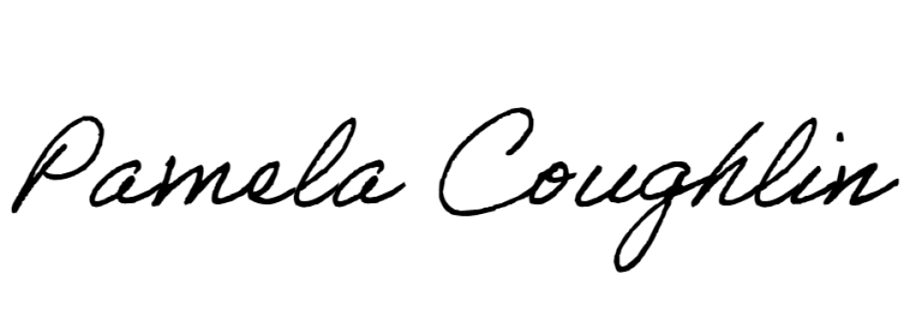
Respectfully submitted,

Pamela Coughlin, Executive Director for
Vickie Pullins, Board Secretary

