West Virginia Board of Examiners for Speech-Language Pathology and Audiology

March 18, 2024
Time: 5:00 PM Board Meeting
Location: Video Conference Meeting Board Office
99 Edmiston Way – Suite 214
Buckhannon, WV 26201

Present: Board President, Vickie Pullins
Board Secretary, Amber Settles
Board Member, Heather Waselchalk
Board Member, Amanda Bonner
Board Member. R. Michael Squires
Board Member, Ruth Rowan

Executive Director, Pamela Coughlin

The March 18, 2024, meeting of the West Virginia Board of Speech-Language Pathology and Audiology was called to order in the Board office at 99 Edmiston Way, Buckhannon, West Virginia, via Zoom at 5:30 PM by Board President Vickie Pullins. Agenda and Zoom invitation were put on the Boards website for the public to attend via telephone.

Pam Coughlin informed the members that we have two hearing aid dealer trainees that passed the ILE test and is ready for the practical. Vickie Pullins stated the board needs to put in place a structural schedule for the hearing aid dealer testing.

Dr. Michael Squires discussed the difference in the testing for Audiology and Hearing Aid Dealer. He recommended we set a date and time once a month for the practical exam. Amanda Bonner and Ruth Rowan agreed with Dr. Squires proctoring the practical once a month. Vickie Pullins recommended they do one month in Parkersburg and the next month in Huntington. Amanda Bonner and Dr. Squires agreed.

Amanda Bonner suggested that she and Dr. Michael Squires review the practical exam material together, that way whoever is proctoring the exam, they will know more about the material that the trainee’s study while they have their permit.

Dr. Michael Squires stated as a board we need to set high expectations for hearing aid dealer trainees so that way they will have skills, confidence, and morals as they become a Hearing Aid Dealer. Vickie Pullins agreed with Dr. Squires and stated as a board, we are here to protect the consumers. It is the board’s job to make sure we are not passing trainees that will do harm to the public.

Vickie Pullins and Ruth Rowan agreed that the integrity that Dr. Michael Squires and Amanda Bonner bring to the board, will create a congruent work for the trainees taking the practical.

Dr. Michael Squires recommended that he and Amanda Bonner have backups if they are unable to proctor the practical. They will come up with a guidebook for the Audiologists or Hearing Aid Dealer that will fill in for them when they are not available.

After discussion on the dates for the practical exam, Amanada Bonner agreed to proctor the practical
Wednesday, April 3, 2024 in Huntington at her office and Dr. Michael Squires will proctor the practical Friday, May 3, 2024 at his office in Parkersburg. Moving forward, the board will post practical exams dates and locations on our website, along with the materials the trainee needs to bring.

Pam Coughlin will get the two trainees scheduled for the practical and then inform Dr. Michael Squires and Amanda. Bonner.

Vickie Pullins mentioned we will need to have a in person Board meeting in April to start working on the proposed rules for hearing aid dealers and add background checks to our Code and Rules.

Amanda Bonner made a motion to adjourn. Ruth Rowan seconded the motion. Motion carried. Meeting adjourned at 6:13 PM.

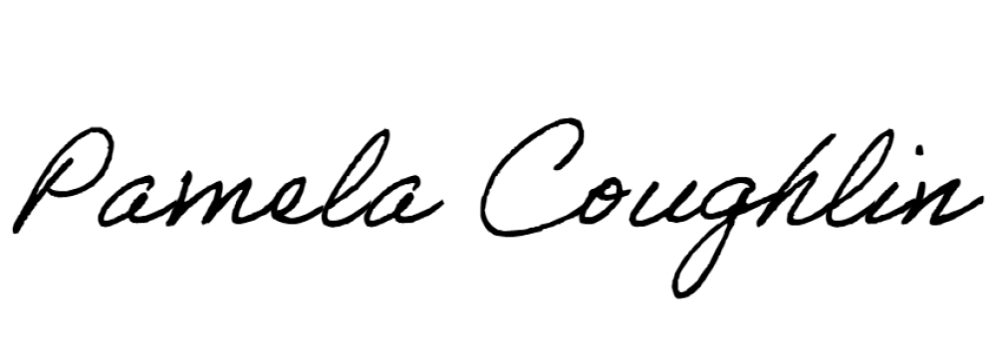
Respectfully submitted,

Pamela Coughlin, Executive Director for
Amber Settles, Board Secretary

