West Virginia Board of Examiners for
Speech-Language Pathology and Audiology

Board Members
Vickie Pullins, M.A., CCC-SLP, President
Amber Settles, M.Ed. CCC-SLP, Secretary

Dr. Michael J. Zagarella, Au.D., CCC-A

R. Michael Squires, Au.D., F-AAA
Heather Waselchalk, M.A. CCC-SLP
Amanda Bonner, Hearing Aid Specialist
Ruth Rowan, Citizen Member

BOARD MEETING AGENDA
March 18, 2024 @ 5:00 PM
Board Office via Video Conference
99 Edmiston Way
Suite 214
Buckhannon, WV 26201

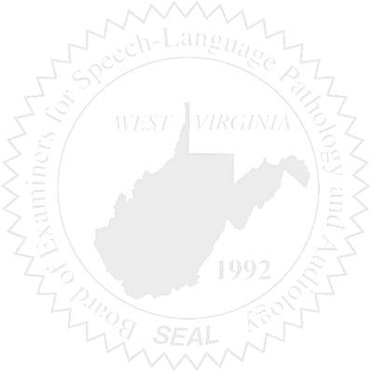
- Call to Order
- Discuss Hearing Aid Dealer exams

