West Virginia Board of Examiners for
Speech-Language Pathology and Audiology

Board Members
Erin Leigh-Ann Browning, M.A., CCC-SLP, President
Vickie Pullins, M.A., CCC-SLP, Secretary

Dr. Michael J. Zagarella, Au.D., CCC-A
Dr. Vernon N. Mullins, Au.D, CCC-A
Joe E. Richards, M.A., Citizen Member

BOARD MEETING AGENDA
August 23, 2021 @ 5:30 PM
Board Office via Video Conference
99 Edmiston Way
Suite 214
Buckhannon, WV 26201

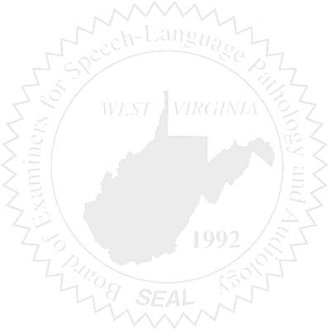
- Call to Order

- Introduction of Board Assistant Attorney General – Joanne Vella

- Board Meeting Minutes Approval – April 21, 2021

- Financial & PCard Reports – Fiscal Year End 2021

COMPLAINT #55 & CE AUDIT

NEW BUSINESS

- New Employee/Hiring

- NCSB Attendees

- NCSB Sponsorship

