West Virginia Board of Examiners for
Speech-Language Pathology and Audiology

Board Members
Erin Leigh-Ann Browning, M.A., CCC-SLP, President
Vickie Pullins, M.A., CCC-SLP, Secretary

Dr. Michael J. Zagarella, Au.D., CCC-A
Dr. Vernon N. Mullins, Au.D, CCC-A
Joe E. Richards, M.A., Citizen Member

BOARD MEETING AGENDA
August 28, 2018 @ 5:00 PM
Board Office via Video Conference
99 Edmiston Way
Suite 214
Buckhannon, WV 26201

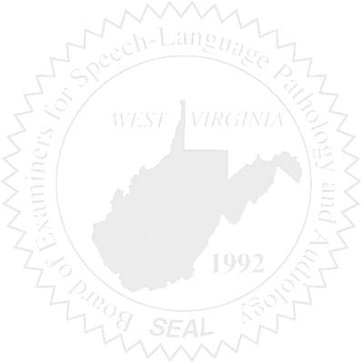
- Call to Order

- CE Broker Demo via Zoom

- Approval of Minutes – July 10, 2018 meeting

- Financial Report

COMPLAINTS

- Case #52 – Update/Patty
- Case #53 – Update/Keith Fisher

OLD BUSINESS

NEW BUSINESS

- NCSB Conference – Sponsorship
- Annual Board Training – Nov. 27th – Charleston
- School SLPs Licensing Stats

