West Virginia Board of Examiners for Speech-Language Pathology and Audiology

October 1, 2024
Time: 5:30 PM Board Meeting
Location: Video Conference Meeting Board Office
99 Edmiston Way – Suite 214
Buckhannon, WV 26201

Present: Board President, Vickie Pullins
Board Secretary, Amber Settles
Board Member, Heather Waselchalk
Board Member, Dr. Michael Zagarella
Board Member, Amanda Bonner
Board Member. Dr. Michael Squires
Board Member, Ruth Rowan
Board Attorney, Joanne Vella

Executive Director, Pamela Coughlin

The October 8, 2024, meeting of the West Virginia Board of Speech-Language Pathology and Audiology was called to order at the Board office at 99 Edmiston Way, Buckhannon, West Virginia, via Zoom at 5:30 PM by Board President Vickie Pullins. Agenda and Zoom invitation were put on the Boards website for the public to attend via telephone.

Dr. Squires made a motion to approve board meeting minutes for July 10, 2024 and August 6, 2024. Ruth Rowan seconded the motion. Motion carried.

Amanda Bonner made motion to approve Pcard for May, June, July and August 2024. Heather Waselchalk seconded the motion. Motion carried.

Pam Coughlin reviewed a renewal application she received for a Hearing Aid Dealer company license on September 17, 2024. Ms. Coughlin informed the Board that the license expired 6/30/2023. The Legislature Rule 8-1-4-3 stated if licensee is late renewing their license, they pay the renewal fee of $120 and a late fee of $120. After a brief discussion, Pam Coughlin will reach out to Cindy Dellinger and see if we can remove Company license from our proposed rules without going back out to public comment.

Vickie Pullins spoke with the Executive Director of the Nebraska Board and they are going through rule changes for the Hearing Aid Dealers scope of practice. Their restrictions are similar to ours and they are willing to help us.

Dr. Squires explained the difference between Cerumen removal and Cerumen management. Ms. Bonner stated International Hearing Society has different model courses you can take to get a certificate for Cerumen removal. Dr. Squires stated International Hearing Society is developing a tinnitus program and you would get a certificate and not a certification.

Dr. Squires reached out to Stephanie Czuhajewski, the Executive Director of Academy of Doctors of Audiology and she is drafting a statement for the Board to review. He also reached out to Dr. Brian Kellermeyer, the President of West Virginia Academy of Otolaryngology. Dr. Squires stated
Dr. Kellermeyer supports our changes to the hearing aid dealers change scope of practice and is willing help any way he can.

Ms. Pullins stated she will reach out American Speech -Language-Hearing Association (ASHA) to get their input on the changes. Amanda Bonner will reach out to International Hearing Society and The American Academy of Audiologists.

Vickie Pullins updated the Board on the meeting she attached virtually on September 3, 2024 with delegate Doug Smith, Cindy Dellinger, Adair Burgess and Pam Coughlin on our proposed rules. Dr. Squires emailed Delegate Fehrenbacher after he heard about the meeting on September 3, 2024 and explained why we made the changes to the scope of practice for hearing aid dealers. Delegate Fehrenbacher is willing to meet with Dr. Squires to review our proposed rule.

Dr. Squires made motion to go into Executive Session at 6:09PM. Amber Settles seconded the motion. Motion carried.

Amber Settles made motion to come out of Executive Session at 7:25PM. Heather Waselchalk seconded to the motion. Motion carried.

Vickie Pullins stated we need additional information regarding training for #58 complaint.

Dr. Zagarella made motion to find probable cause of violations of our Practice Act for complaint #59. Amber Settles seconded the motion. Motion carried.

Amanada Bonner made motion to find probable cause of violations of our Practice Act for complaint #61. Ruth Rowan seconded the motion. Motion carried.

Amanda Bonner made motion to adjourn. Dr. Michael Zagarella seconded motion. Motion carried.

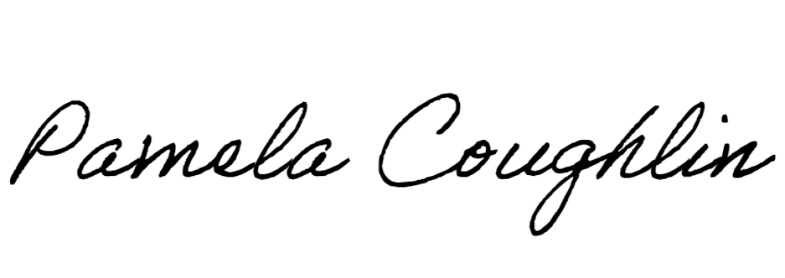
Respectfully submitted,

Pamela Coughlin, Executive Director
for
Amber Settles, Board Secretary

