West Virginia Board of Examiners for
Speech-Language Pathology and Audiology

Board Members
Vickie Pullins, M.A., CCC-SLP, President
Amber Settles, M.Ed. CCC-SLP, Secretary

Dr. Michael J. Zagarella, Au.D., CCC-A

R. Michael Squires, Au.D., F-AAA
Heather Waselchalk, M.S. CCC-SLP
Amanda Bonner, Hearing Aid Specialist
Ruth Rowan, Citizen Member

Pamela Coughlin, Executive Director

December 4, 2025

BOARD MEETING AGENDA
VIA ZOOM CONFERENCE
99 EDIMISTON WAY, SUITE 214
BUCKHANNON, WV 26201

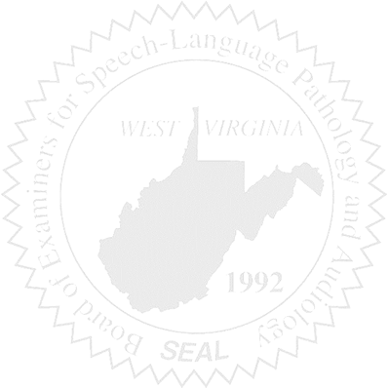
- Call to order

Old Business

- Audiologist licensed as a Hearing Aid Dealers.

New Business

- Discuss Executive Director Salary

