West Virginia Board of Examiners for Speech-Language Pathology and Audiology

April 23, 2026
Time: 5:30 PM Board Meeting
Location: Video Conference Meeting Board Office
99 Edmiston Way – Suite 214
Buckhannon, WV 26201

Present: Board President, Amber Settles
Board Secretary, Heather Waselchalk
Board Member, Dr. Michela Zagarella
Board Member, Dr. Michael Squires
Board Member, Vickie Pullins
Board Member, Amanda Bonner
Board Member, Ruth Rowan
Board Attorney, Joanne Vella

Executive Director, Pamela Coughlin

The April 23, 2026 meeting of the West Virginia Board of Speech-Language Pathology and Audiology was called to order at the Board office at 99 Edmiston Way, Buckhannon, West Virginia, via Zoom at 5:30 PM by Board President Vickie Pullins. Agenda and Zoom invitation were put on the Boards website for the public to attend via telephone.

Amanda Bonner made a motion to approve board meeting minutes for January 15, 2026. Ruth Rowan seconded the motion. Motion carried.

Vickie Pullins made a motion to approve Pcard for December 2025, January and February 2026. Amanda Bonner seconded the motion. Motion carried.

Amanda Bonner made a motion to approve the financials for April 17, 2026. Dr. Michael Zagarella seconded to motion. Motion carried.

Pam Coughlin reviewed email regarding sponsorship for the American Academy of Audiology's national conference.

Ms. Pullins and Dr. Zagarella have indicated that the Board is open to sponsoring the West Virginia Audiology conference, contingent upon the attendance of our Board Audiologist.

Dr. Zagarella is currently reviewing the sponsorship details for the West Virginia group and will provide an update to the Board

Dr. Zagarella made a motion to sponsor the National Council of State Board of Examiners conference in Denver, Colorado, taking place from October 1st through October 3, 2026, in the amount of $1,500.
Ms. Pullins seconded the emotion.

Ms. Coughlin reviewed the initial licensee records with the Board regarding the privilege to practice in West Virginia.

During this verification process, it was discovered that although you attested to completing the required Jurisprudence exam, our records indicate that you have not yet taken it.

The Board office reached out to the licensees and asked them to take the Jurisprudence exam at your earliest convenience and all licensees completed the exam in a timely manner.

Pam Coughlin reviewed the $350 fee for the West Virginia Association of Licensing Board Fee.

Ms. Coughlin informed Board that we need to file an emergency Legislative Rule to incorporate the initial license and renewal fees for the Interstate Compact.

Ms. Pullins consulted with Nahale Kalfas, legal counsel for the Interstate Compact, who advised that these fees must be documented within our Legislative Rules. Furthermore, our Board counsel, Joanne Vella, has agreed that this action is necessary to ensure we remain in compliance.

Amanda Bonner made a motion to file an emergency rule. Vickie Pullins seconded the motion. Motion carried.

Ms. Coughlin informed the Board that Adair Burgess has left the Legislature and Phillip Childs will be taking her place.

Ms. Coughlin informed the Board she will working on proposed Legislative Rules for Speech- Language Pathology, Audiology and Hearing Aid Dealers.

Ms. Coughlin consulted with Mr. Childs regarding the possibility of keeping the WV Code and Legislative rules for Speech-Language Pathology and Audiology separate from those for Hearing Aid Dealers. He indicated that he does not see any issues with this approach.

Dr. Squires has informed the Board of an individual he would like to hire as an Audiology Assistant who is currently a certified medical assistant.

However, WV Code 30-32-15-1 requires that an applicant possess a minimum of an associate's degree from an institution or technical training program with a program of study specifically designed to prepare the student to be a speech-language pathology or audiology assistant.

Dr. Zagarella has indicated that we need to refine our rule to be clearer regarding technical programs or specify that they must be Board-approved.

To assist with this, Dr. Squires will be reaching out to colleagues to identify the specific training programs completed by their Audiology Assistants. Additionally, Ms. Pullins will be contacting the Boards in Louisiana, North Carolina, and Ohio for further information.

Amber requested to share any findings from other states or colleagues regarding Audiology Assistant programs with the Board so that we can proceed with updating the rule.

Dr. Squires made a motion to go into Executive Session. Amanda Bonner seconded the motion. Motion carried.

Dr. Zagarella made a motion to come out of Executive Session. Dr. Squires seconded the motion. Motion carried.

Complaint #6 has been dismissed. The consumer received a full refund for the hearing aids she purchased, resolving the matter.

Vickie Pullins moved to conduct further investigation into the company involved in complaint #7. The motion was seconded by Heather Waselchalk. Motion carried.

Dr. Squires moved to open the complaints received from the Attorney General’s office. The motion was seconded by Ruth Rowan. Motion carried.

Ms. Pullins made a motion to adjourn. Ruth Rowan seconded the motion. Motion carried.

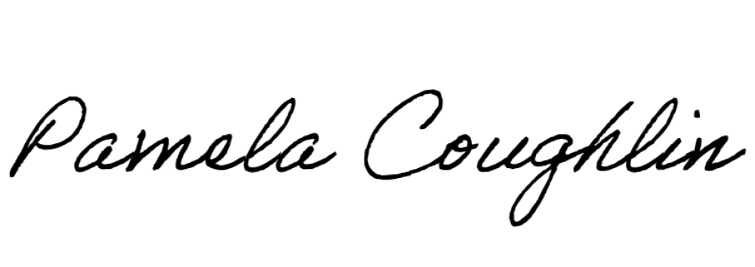
Respectfully submitted,

Pamela Coughlin, Executive Director
for
Amber Settles, Board Secretary

