West Virginia Board of Examiners for
Speech-Language Pathology and Audiology

Board Members
Vickie Pullins, M.A., CCC-SLP, President
Amber Settles, M.Ed. CCC-SLP, Secretary

Dr. Michael J. Zagarella, Au.D., CCC-A

R. Michael Squires, Au.D., F-AAA
Heather Waselchalk, M.S. CCC-SLP
Amanda Bonner, Hearing Aid Specialist
Ruth Rowan, Citizen Member

Pamela Coughlin, Executive Director

November 4, 2025

BOARD MEETING AGENDA
VIA ZOOM CONFERENCE
99 EDIMISTON WAY, SUITE 214
BUCKHANNON, WV 26201

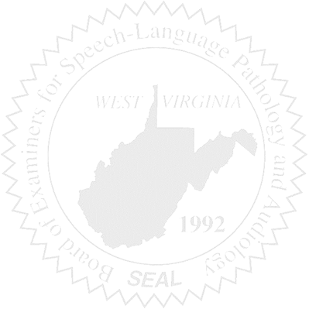
- Call to order
- Board Meeting Minutes for July 8, 2025
- PCard for June, July August, September of 2025
- Financials for the end of FY 2025
- Current Financials

New Business

- NCSB Conference update
- Compact Launch and Fees
- Transferred funds to General Revenue at the end of FY 2025
- Audiologist licensed as a Hearing Aid Dealers.
- International Hearing Society increase in fee increase for ILE exam

