West Virginia Board of Examiners for
Speech-Language Pathology and Audiology

Board Members

Dr. Michael J. Zagarella, Au.D., CCC-A, President
Vickie Pullins, M.A., CCC-SLP, Secretary
Dr. Vernon N. Mullins, Au.D, CCC-A
Erin Leigh-Ann Browning, M.A., CCC-SLP
Joe E. Richards, M.A., Citizen Member

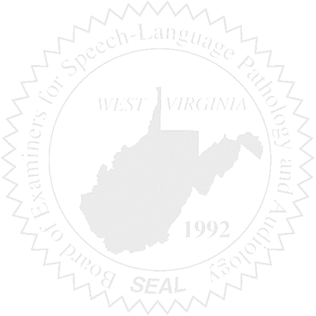
BOARD MEETING
May 18, 2016
5:30 PM
Board Office via Video Conference
99 Edmiston Way – Suite 214
Buckhannon, WV 26201

- Call to Order

- Approval of Minutes – April 15, 2016

- Financial Report including Purchasing Card expenditures, etc.

- Complaints
- #44 Supervisor of unlicensed CF – Report to the Board re: Hearing
- Elissa Lindsay Appeal Update, if any
- #Complaint #46 – SLP working outside scope of practice

5. Old Business
- Sanctioning Guidelines
- Update of 29-5 Code of Ethics
- Budget amendment - Patty

6. New Business

