West Virginia Board of Examiners for
Speech-Language Pathology and Audiology

Board Members
Erin Leigh-Ann Browning, M.A., CCC-SLP, President
Vickie Pullins, M.A., CCC-SLP, Secretary

Dr. Michael J. Zagarella, Au.D., CCC-A
Dr. Vernon N. Mullins, Au.D, CCC-A
Joe E. Richards, M.A., Citizen Member

BOARD MEETING AGENDA
May 23, 2018 @ 5:00 PM
Board Office via Video Conference
99 Edmiston Way
Suite 214
Buckhannon, WV 26201

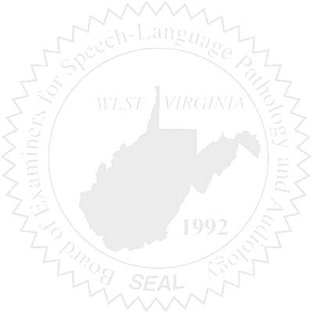
- Call to Order

- Assistant Attorney General – Keith Fisher introduction

- Approval of Minutes – April 23, 2018 Meeting

- PCard & Board Financials

- Complaints –
- Complaint #52 – Unprofessional Conduct & Unlicensed Supervision
- Complaint #53 - Update
- Complaint #44 – Bearden Hearing #2 – Update

- Old Business

- New Business
- Purchasing Inspection/Audit Report

