West Virginia Board of Examiners for
Speech-Language Pathology and Audiology

Board Members
Dr. Vernon N. Mullins, Au.D, CCC-A, President
Vickie Pullins, M.A., CCC-SLP, Secretary

Dr. Michael J. Zagarella, Au.D., CCC-A
Erin Leigh-Ann Browning, M.A., CCC-SLP,
Joe E. Richards, M.A., Citizen Member

BOARD MEETING AGENDA
January 11, 2023 @ 5:00 PM
Board Office via Video Conference
99 Edmiston Way
Suite 214
Buckhannon, WV 26201

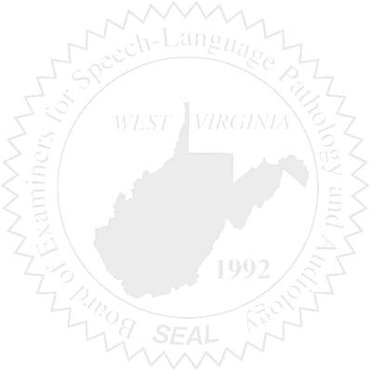
- Call to Order

- Board Meeting Minutes Approval- October 26, 2022

- Financials for November and December 2022 & PCard Report

NEW BUSINESS

- New item for Jurisprudence Exam.
- Necessity of Approval for CE activities not already approved by ASHA, AAA, etc.

- FARB Conference
- Edit Mission Statement
- New Board Members
- Annual vote
- Hiring Assistant
- Erin Resigning

OLD BUSINESS

- Complaint #55

