West Virginia Board of Examiners for
Speech-Language Pathology and Audiology

Board Members

Dr. Michael J. Zagarella, Au.D., CCC-A, President
Vickie Pullins, M.A., CCC-SLP, Secretary
Dr. Vernon N. Mullins, Au.D, CCC-A
Erin Leigh-Ann Browning, M.A., CCC-SLP
Joe E. Richards, M.A., Citizen Member

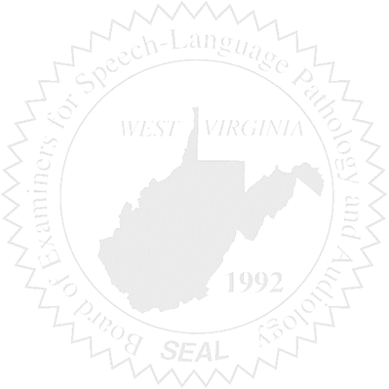
BOARD MEETING
January 26, 2017 - Thursday
5:00 PM
Board Office via Video Conference
99 Edmiston Way – Suite 214
Buckhannon, WV 26201

- Call to Order

- Approval of Minutes – September 14, 2016

- Financial & PCard Report

- Complaints – Greg Foster, Attorney
- Complaint #46 – SLP working outside scope of practice
- Complaint #44 Supervisor of unlicensed Clinical Fellow - update
- Elissa Lindsay Appeal Update, if any – Writ of Mandamus?????

5. Old Business
- Ronald Warrington License Application Review

6. New Business
- Election of Officers
- NCSB travel (Vickie)
- Office Equipment Issues
- License Renewal Process Discussion

