West Virginia Board of Examiners for
Speech-Language Pathology and Audiology

Board Members
Erin Leigh-Ann Browning, M.A., CCC-SLP, President
Vickie Pullins, M.A., CCC-SLP, Secretary

Dr. Michael J. Zagarella, Au.D., CCC-A
Dr. Vernon N. Mullins, Au.D, CCC-A
Joe E. Richards, M.A., Citizen Member

BOARD MEETING AGENDA

October 22, 2019 @ 5 PM
Board Office via Zoom Video Conference
99 Edmiston Way, Suite 214
Buckhannon, WV 26201

- Call to Order

- Approval of Minutes – September 18, 2019 meeting

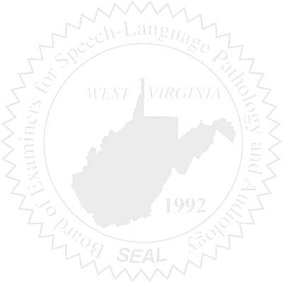
OLD BUSINESS

- Board approval of Rule 29-1 & 29-4 revision(s)

NEW BUSINESS

- SLP Scope of Practice Discussion
- Next Meeting Date

