West Virginia Board of Examiners for
Speech-Language Pathology and Audiology

Board Members
Erin Leigh-Ann Browning, M.A., CCC-SLP, President
Vickie Pullins, M.A., CCC-SLP, Secretary

Dr. Michael J. Zagarella, Au.D., CCC-A
Dr. Vernon N. Mullins, Au.D., CCC-A
Joe E. Richards, M.A., Citizen Member

BOARD MEETING AGENDA

February 15, 2022 @ 5 PM
Board Office via Zoom Video Conference
99 Edmiston Way, Suite 214
Buckhannon, WV 26201

- Call to Order
- Gregg Thornton – Ohio Board & HAD
- Approval of minutes
- Financials and PCard

OLD BUSINESS

- Complaint #55
- FARB – Vickie

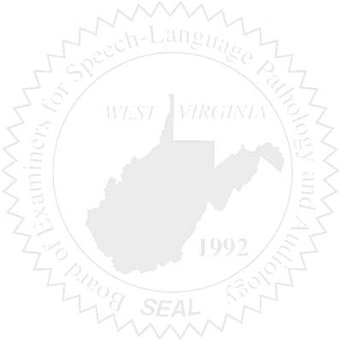
NEW BUSINESS

- Copier Lease
- Correctional Industries & Printing
- Regulatory Software
- Legislative Bills

