West Virginia Board of Examiners for
Speech-Language Pathology and Audiology

Board Members
Erin Leigh-Ann Browning, M.A., CCC-SLP, President
Vickie Pullins, M.A., CCC-SLP, Secretary

Dr. Michael J. Zagarella, Au.D., CCC-A
Dr. Vernon N. Mullins, Au.D, CCC-A
Joe E. Richards, M.A., Citizen Member

BOARD MEETING AGENDA
April 21, 2021 @ 5:00 PM
Board Office via Video Conference
99 Edmiston Way
Suite 214
Buckhannon, WV 26201

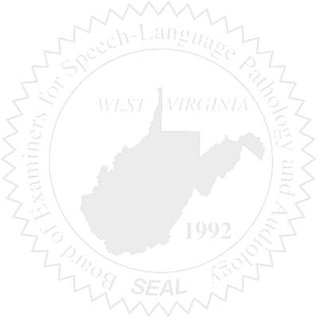
- Call to Order

- Board Meeting Minutes Approval – February 17th & March 11th

- Financial & PCard Reports

COMPLAINT & CE AUDIT RESULTS

OLD BUSINESS

- Renewal Stats – tabled 02/17 meeting

- ASHA Committee of Ambassadors – tabled 02/17 meeting

NEW BUSINESS

- Emergency Rule §29-1 – Interstate Telepractice

- Interstate Compact Board of Directors

- Marshall University SLPA Program/Board Response

- Thentia – Regulatory Software

