West Virginia Board of Examiners for

Speech-Language Pathology and Audiology

Board Members

Vickie Pullins, M.A., CCC-SLP, President

Amber Settles, M.Ed. CCC-SLP, Secretary

Dr. Michael J. Zagarella, Au.D., CCC-A

R. Michael Squires, Au.D., F-AAA

Heather Waselchalk, M.S. CCC-SLP

Amanda Bonner, Hearing Aid Specialist

Ruth Rowan, Citizen Member

Pamela Coughlin, Executive Director

July 8, 2025

BOARD MEETING AGENDA

VIA ZOOM CONFERENCE

99 EDIMISTON WAY, SUITE 214

BUCKHANNON, WV 26201

1. 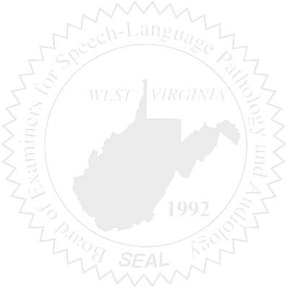Call to order
2. Approve April Pcard
3. Approve May 15, 2025 Minutes

New Business

1. Fee for Compact
2. Sponsor NCSB
3. NCSB, September 18th thru 20th in Mt. Pleasant, SC. Who is attending?
4. CMS update

Old Business

1. CE Audit- Discuss licensee that was late sending CE.
2. Hearing Aid Dealer Company license update