West Virginia Board of Examiners for

Speech-Language Pathology and Audiology

Board Members

Vickie Pullins, M.A., CCC-SLP, President

Amber Settles, M.Ed. CCC-SLP, Secretary

Dr. Michael J. Zagarella, Au.D., CCC-A

R. Michael Squires, Au.D., F-AAA

Heather Waselchalk, M.S. CCC-SLP

Amanda Bonner, Hearing Aid Specialist

Ruth Rowan, Citizen Member

Pamela Coughlin, Executive Director

BOARD MEETING AGENDA

VIA ZOOM CONFERENCE

99 EDIMISTON WAY, SUITE 214

BUCKHANNON, WV 26201

1. 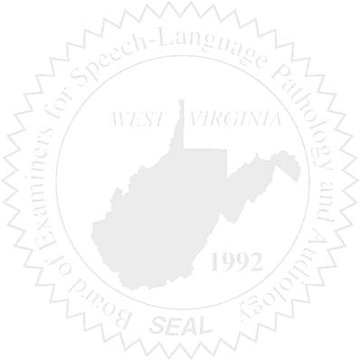Call to order
2. Approve January 21, 2025 minutes
3. Approve December 2024, January & February, March 2025 Pcard.

New Business

1. WVSHA March Silver Package ($100) March 27,2025 and March 28, 2025 @ Lakeview Golf Resort in Morgantown.
2. Review CE Audit.
3. Budget FY2026
4. Supervising 2 Hearing Aid Dealer trainees.
5. Criminal Background has been added to our Practice Act.
6. Criminal Background process has been started with the State Police.
7. Software approval for the Interstate Compact has been submitted to Office of Technology.
8. Sponsoring Mountain State Conference for Disabilities.

Complaints

1. Update on #59 & #61 (consent agreement, Admin Judge, recorder, date and time of hearing, etc. (June 17th)
2. HAD Complaint #5 (received 3/21/2025) Acknowledgement & Response letters sent 3/25/2025 & 4/25/2025