West Virginia Board of Examiners for Speech-Language Pathology and Audiology

May 15, 2025
Time: 5:30 PM Board Meeting
Location: Video Conference Meeting Board Office
99 Edmiston Way – Suite 214
Buckhannon, WV 26201

Present: Board President, Vickie Pullins
Board Secretary, Amber Settles
Board Member, Dr. Michael Zagarella
Board Member, Heather Waselchalk
Board Member, Amanda Bonner
Board Member, Ruth Rowan
Board Attorney, Joanne Vella

Executive Director, Pamela Coughlin

The May 15, 2025, meeting of the West Virginia Board of Speech-Language Pathology and Audiology was called to order at the Board office at 99 Edmiston Way, Buckhannon, West Virginia, via Zoom at 5:30 PM by Board President Vickie Pullins. Agenda and Zoom invitation were put on the Boards website for the public to attend via telephone.

Amber Settles made a motion to approve the agenda. Amanda Bonner seconded the motion. Motion carried.

Ruth Rowan made a motion to approve board meeting minutes for January 21, 2025. Amber Settles seconded the motion. Motion carried.

Heather Waselchalk made a motion to approve Pcard for December 2024, January, February and March 2025. Amanda Bonner seconded the motion. Motion carried.

Dr. Michael Zagarella made a motion not to sponsor the Mountain State Conference for Disabilities. Amanada Bonner seconded the motion. Motion carried.

Pam Coughlin reviewed the continuing education audit. Dr. Michael Zagarella recommended to send a certified letter to the employer and to the licensees that have not sent all the continuing education to the Board. As for the discipline for the licensees that were short on continuing education, the Board agreed to have the licensees to take an extra hour of ethics and pay a $75 late fee.

Pam Coughlin reviewed the FY 2026 Budget with Board. Ruth Rowan made a motion to accept the Budget for FY 2026. Heather Waselchalk seconded the motion. Motion carried.

Pam Coughlin asked the Board if a Hearing Aid Dealer could supervise 2 trainees and due to the Legislative Rule §8-1-4-8, we cannot make an exemption.

Pam Coughlin informed the Board the Background Check has been added to our Practice Act and the process has been started with State Police and FBI.

Pam Coughlin informed the Board the Interstate Compact software approval has been submitted to the WV Office of Technology for approval.

Amanda Bonner made a motion to go into Executive Session. Amber Settles seconded the motion. Motion carried.

Dr. Zagarella motioned to come out of Executive Session. Ruth Rowan seconded the motion. Motion carried.

Dr. Zagarella made a motion dismiss complaint #5 for no probable cause. Ruth Rowan seconded the motion. Motion carried.

Dr. Zagarella made a motion to have Pam Coughlin follow up on the status of company license for complaint #5. Amber Settles seconded the motion. Motion was carried.

Amber Settles made motion to adjourn. Amanda Bonner seconded motion. Motion carried.

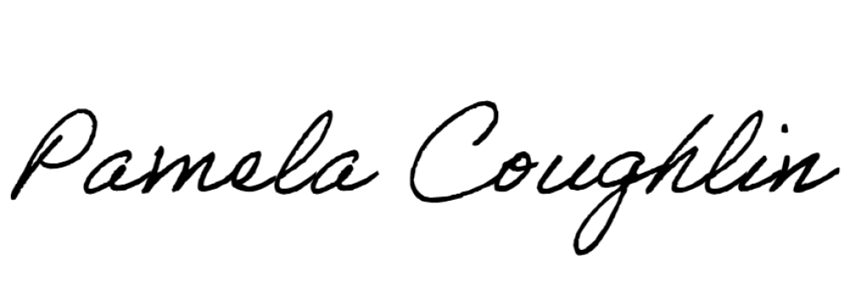
Respectfully submitted,

Pamela Coughlin, Executive Director
for
Amber Settles, Board Secretary

