West Virginia Board of Examiners for Speech-Language Pathology and Audiology

April 9, 2024
Time: 5:00 PM Board Meeting
Location: Video Conference Meeting Board Office
99 Edmiston Way – Suite 214
Buckhannon, WV 26201

Present: Board President, Vickie Pullins
Board Secretary, Amber Settles
Board Member, Heather Waselchalk
Board Member, Dr. Michael Zagarella
Board Member, Amanda Bonner
Board Member. Dr. Michael Squires
Board Member, Ruth Rowan
Assistant Attorney General, JoAnne Vella

Executive Director, Pamela Coughlin

The April 9, 2024, meeting of the West Virginia Board of Speech-Language Pathology and Audiology was called to order at the Board office at 99 Edmiston Way, Buckhannon, West Virginia, via Zoom at 5:30 PM by Board President Vickie Pullins. Agenda and Zoom invitation were put on the Boards website for the public to attend via telephone.

Ruth Rowan motioned to approve minutes for February 13, 2024 and March 18,2024. Amber Settles seconded the motion. Motion carried.

Dr. Michael Squires motioned to approve Pcard reports for December, January and February 2024 as submitted. Ruth Rowan seconded the motion. Motion carried.

Vickie Pullins stated for our board to operate sufficiently, the members need to respond to emails, calls and texts within 24 hours or sooner. Ms. Pullins asked the members to let Pam Coughlin know when they are on vacation or out of the country.

Pam Coughlin reviewed a hearing aid dealer trainee application that she received on March 18, 2024. The applicant was on supervised probation from October 5, 2020 to October 5, 2021 for conspiracy to commit possession with intent to deliver controlled substance “Marijuana”. The board members agreed the applicant did their time and deserves a second chance. Members approved to issue a hearing aid dealer trainee permit.

Vickie Pullins informed the members that the board office lease was signed for another 5 year.

We are meeting on Saturday, May 4, 2025 from 10:00AM to 2:00PM at the board office at 99 Edmiston Way in Buckhannon to work on the proposed rules and adding background checks for Speech Pathologists and Audiologists. Mr. Pullins explained to the members that we will have to open up the WV Code to make these changes for SLP’S and AUD. She informed the board that the Interstate Compact is scheduled to go active this coming fall.

Vickie Pullins asked the board members if they would consider working on a Legislative bill to address the credential “Audioprosthology” that Hearing Aid Dealers use due to it is a certification and not a license. Dr. Michael Squires explained our licensure does not acknowledge “Audioprosthologist” which creates a marketing confusion to the consumer. Amanda Bonner stated that Hearing Aid Fitters have to be licensed with the Board and certified to use additional credentialing like, Audioprosthology and Hearing Instrument Specialist (HIS).

Amber Settles made a motion to go into Executive Session at 5:51PM to discuss the complaints. Ruth Rowan seconded the motion. Motion carried.

Dr. Michael Squires recused himself for Complaint #59. Amanda Bonner recused herself for Complaint #3. Both returned to the meeting after the discussion of the complaints.

Dr. Michael Squires made a motion to come out of Executive Session at 6:57PM. Ruth Rowan seconded the motion. Motion carried.

Vickie Pullins informed the members that we needed to schedule another board meeting soon to review complaint #60. Board meeting will be scheduled on April 22, 2024 at 5:30 PM.

Dr. Michael Squires made a motion to adjourn. Ruth Rowan seconded the motion. Motion carried. Meeting adjourned at 7:04 PM.

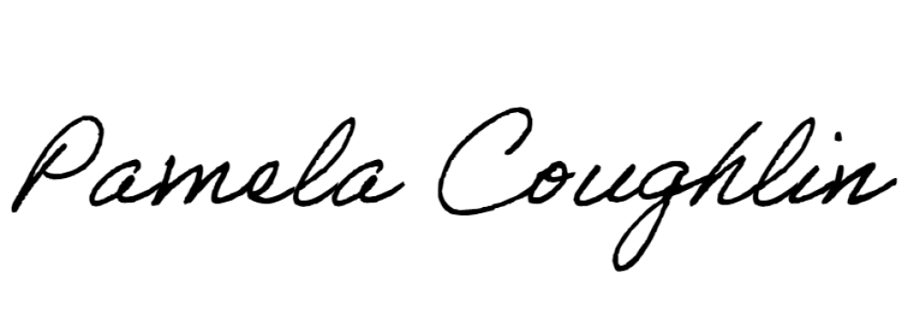
Respectfully submitted,

Pamela Coughlin, Executive Director
for
Amber Settles, Board Secretary

