West Virginia Board of Examiners for
Speech-Language Pathology and Audiology

Board Members
Erin Leigh-Ann Browning, M.A., CCC-SLP, President
Vickie Pullins, M.A., CCC-SLP, Secretary

Dr. Michael J. Zagarella, Au.D., CCC-A
Dr. Vernon N. Mullins, Au.D, CCC-A
Joe E. Richards, M.A., Citizen Member

BOARD MEETING AGENDA

January 11, 2022 @ 5 PM
Board Office via Zoom Video Conference
99 Edmiston Way, Suite 214
Buckhannon, WV 26201

- Call to Order
- Election of Officers
- Financials and PCard Reports
- Approval of Minutes – August 23, 2021

OLD BUSINESS

- Complaint #55
- Update Board on NCSB Conference – Vickie
- Hearing Aid Dealers Board - Joe

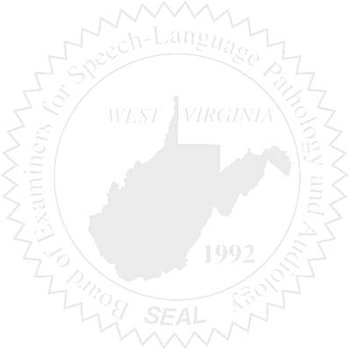
NEW BUSINESS

- FARB
- WVSHA
- Patty’s Retirement – Board approval of WV-48

