West Virginia Board of Examiners for
Speech-Language Pathology and Audiology

Board Members
Erin Leigh-Ann Browning, M.A., CCC-SLP, President
Vickie Pullins, M.A., CCC-SLP, Secretary

Dr. Michael J. Zagarella, Au.D., CCC-A
Dr. Vernon N. Mullins, Au.D, CCC-A
Joe E. Richards, M.A., Citizen Member

BOARD MEETING AGENDA

February 19, 2019 @ 5:00 PM
Board Office via Video Conference
99 Edmiston Way
Suite 214
Buckhannon, WV 26201

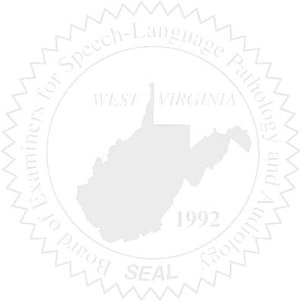
- Call to Order

- Approval of Minutes – August 28, 2018 & January 8, 2019 Meetings

- Financial & PCard Report

COMPLAINTS

- Case #53 – Update/Keith Fisher, Board Attorney

OLD BUSINESS

- Case #52 – supervised probation plan
- FARB & CE Broker – Erin
- Continuing Education – Audit or Submission Date or ??
- Rules Change

NEW BUSINESS

- WVSHA – Vendor Table & Meeting Date
- NCSB Planning Meeting/Travel
- WVU Grad Student Presentation – Erin
- WVU Grad Student Office Intern

