West Virginia Board of Examiners for Speech-Language Pathology and Audiology

June 14, 2023 Board Meeting
Time: 5:00 PM
Location: Video Conference Meeting Board Office
99 Edmiston Way – Suite 214
Buckhannon, WV 26201

Present: Board President, Vernon Mullins Board Secretary, Vickie Pullins Board Member, Michael Zagarella Board Member, Heather Waselchalk Board Member, Amber Settles
Citizen Member, Joe E. Richards
Joanne Vella- Board Council
Executive Director, Pamela Coughlin – Board Office

The meeting was called to order at 5:00 PM by Vernon Mullins, Board President.
Joe Richards reviewed the process for filing our Proposal Rules to the Secretary of State for public comment.

Michael Zagarella made a motion to approve draft Proposal rules as presented for public comment. Joe Richards seconded the motion. Motion carried

Joe Richards explained to the new board members, Heather Waselchalk and Amber Settles that they do not have a vote until they are confirmed with the Senate. Joe said an interim meeting will be scheduled late August 2023 or the beginning of September 2023 for the new members to be sworn in.

Amanda Bonner reviewed her concern about the 4 individuals that are scheduled for the practical in the month of June. Board members instructed Amanda to continue with the practical.

Amanda Bonner stated she has 2 individuals that are applying for Apprenticeship in June 2023. Board members suggested the 2 individuals wait until after the sunset of the Hearing Aid Board.

Joe Richards made a motion to approve all reports as presented. Vickie Pullins seconded the motion. Motion carried.

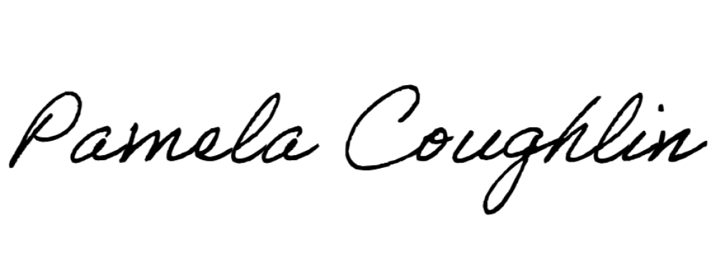
Respectfully submitted,

Pamela Coughlin, Executive Director for
Vickie Pullins, Board Secretary

