West Virginia Board of Examiners for
Speech-Language Pathology and Audiology

Board Members
Dr. Vernon N. Mullins, Au.D, CCC-A, President
Vickie Pullins, M.A., CCC-SLP, Secretary

Dr. Michael J. Zagarella, Au.D., CCC-A
Amber Settles, M.Ed. CCC-SLP
Heather Waselchalk, M.A. CCC-SLP
Amanda Bonner, Hearing Aid Specialist
Joe E. Richards, M.A., Citizen Member

BOARD MEETING AGENDA
July 24, 2023 @ 5:00 PM
Board Office via Video Conference
99 Edmiston Way
Suite 214
Buckhannon, WV 26201

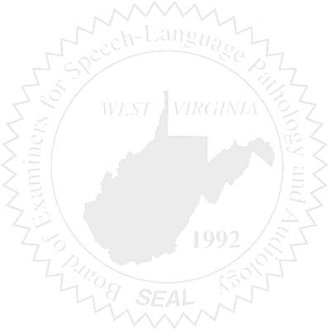
- Call to Order

- Vote on Proposed Rules changes.

