West Virginia Board of Examiners for
Speech-Language Pathology and Audiology

Board Members
Erin Leigh-Ann Browning, M.A., CCC-SLP, President
Vickie Pullins, M.A., CCC-SLP, Secretary

Dr. Michael J. Zagarella, Au.D., CCC-A
Dr. Vernon N. Mullins, Au.D, CCC-A
Joe E. Richards, M.A., Citizen Member

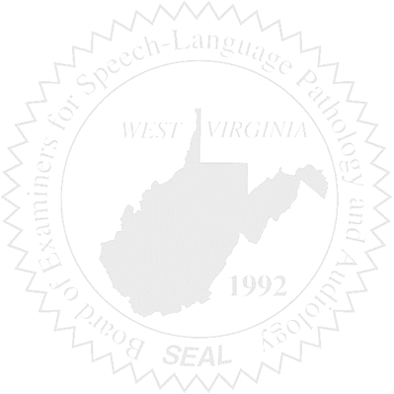
BOARD MEETING
June 7, 2017 @ 6:00 PM
Board Office via Video Conference
99 Edmiston Way
Suite 214
Buckhannon, WV 26201

- Call to Order

- Approval of Minutes – May 3, 2017 Meeting

- Cash Balance & PCard Purchasing Report

- Complaints – Updates
- Complaint #44 Supervisor of unlicensed Clinical Fellow – Hearing Update
- Elissa Lindsay Appeal Update, if any – Writ of Mandamus
- Complaint #50

- Old Business
- PPE Supervision Document(s) review
- Consultants’ Invoice approval

- New Business
- Gary Harris Letter

