West Virginia Board of Examiners for Speech-Language Pathology and Audiology

July 20, 2023 Board Meeting
Time: 5:00 PM
Location: Video Conference Meeting Board Office
99 Edmiston Way – Suite 214
Buckhannon, WV 26201

Present: Board President, Vernon Mullins Board Secretary, Vickie Pullins Board Member, Michael Zagarella Board Member, Heather Waselchalk Board Member, Amber Settles
Citizen Member, Joe E. Richards
Joanne Vella- Board Council
Executive Director, Pamela Coughlin – Board Office

Vern Mullins opened the meeting with the boards Mission Statement.
The meeting was called to order at 5:0 1PM by Vernon Mullins, Board President.
Vern Mullins asked Pam Coughlin to review the changes the board members submitted on the proposed rules. Amanda Bonner asked if we could change the name for Hearing Aid Dealer to Hearing Aid Specialists. Joe Richards explained HB4333 has them listed Hearing Aid Dealer. Name will stay the same unless Legislature changes the name.

Michael Zagarella requested we change master’s degree to Doctorate of Audiology under qualification for Audiologist. Vickie Pullins suggested we change the payment option for Hearing Aid Dealers from Certified check to just payment.

Amanda Bonner reviewed the process of getting a Hearing Dealer license and discussed the practical test that Dr. Nancy Gillespie’s will preform for 3 individuals on June 28, 2023. Pam Coughlin will contact Oasis and see how to pay Dr. Gillispie since the Hearing Aid Board sunset on July 1, 2023.

Vern Mullins recommended changing Hearing Aid Dealer education requirement to an Associates Degree. Amanda Bonner stated the Hearing Aid Dealer gets their training during apprenticeship.

Vickie Pullins recommended Amanda Bonner educates the board on the Hearing Aid Dealer license process of licensing.

Vickie Pullins made a motion to adjourn. Joe Richards seconded the motion. The meeting adjourned at 7:16 PM.

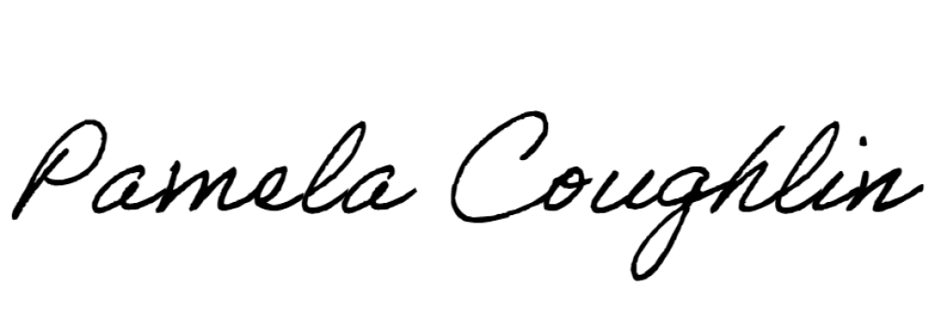
Respectfully submitted,

Pamela Coughlin, Executive Director for
Vickie Pullins, Board Secretary

