West Virginia Board of Examiners for
Speech-Language Pathology and Audiology

Board Members
Dr. Vernon N. Mullins, Au.D., CCC-A,, President
Vickie Pullins, M.A., CCC-SLP, Secretary

Dr. Michael J. Zagarella, Au.D., CCC-A
Erin Leigh-Ann Browning, M.A., CCC-SLP
Joe E. Richards, M.A., Citizen Member

Patricia J. Nesbitt, Executive Director

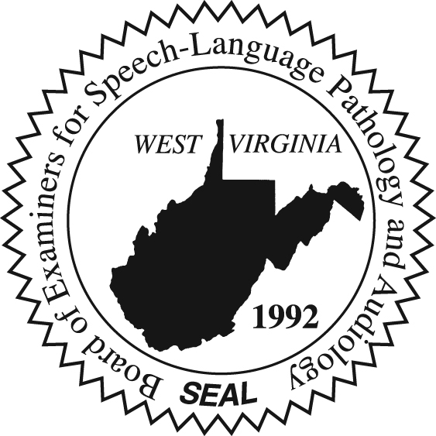

BOARD MEETING AGENDA

May 3, 2022 @ 5:00 PM
Board Office via Zoom Video Conference
99 Edmiston Way, Suite 214
Buckhannon, WV 26201

- Call to Order
- Complaint #55

